SUJATHA GLOBAL COMPANY LIMITED

Njombe, Tanzania | www.sujathaglobal.co.tz | info@sujathaglobal.co.tz

1. Company Overview

Founded in Njombe, Tanzania, SUJATHA GLOBAL COMPANY LIMITED is an innovative, value-driven general trading firm specializing in premium foodstuffs and wood products. Leveraging strategic supplier relationships across East Africa, we deliver carefully sourced Avocado, Avocado Oil, Maize, Pigeon Beans, Soybean and Rice alongside high-grade Eucalyptus Veneer and Pine Timber. Our customer-centric approach and commitment to quality at competitive prices have fueled continuous growth and opened limitless opportunities for expansion.

2. Mission

To supply consistently superior products at the best market prices, empowering partners with reliable, timely deliveries and exceptional service.

Mission

3. Vision

To become East Africa’s most trusted general trader—recognized for innovation, integrity and a steadfast dedication to customer success.

4. Core Values

• Quality First: We rigorously select and inspect every product to ensure consistent freshness, purity and performance.

• Value Creation: By optimizing our procurement and logistics, we pass cost savings on to customers without compromising standards.

• Reliability: On-time delivery and transparent communication are the hallmarks of our service.

• Integrity: Ethical sourcing, fair trade practices and environmental stewardship guide every decision.

• Innovation: We continually refine processes, explore new markets and adopt technology to enhance supply-chain efficiency.

**Partner with SUJATHA GLOBAL for Quality Products & Reliable Supply**

5. Product Portfolio

A. Food Products

– Avocado (fresh, variety-graded)

– Avocado Oil (cold-pressed, food-grade)

**Premium Food Products, Quality Wood Products, Reliable Export Logistics and 24/7 Customer Support**

– Maize (white and yellow kernels)

– Pigeon Beans (high-protein varieties)

– Soybean (non-GMO, feed-grade and food-grade)

– Rice (parboiled, long-grain and medium-grain)

B. Wood Products

– Eucalyptus Veneer (precision-cut, custom thickness)

– Pine Timber (graded, kiln-dried)

– Additional species and value-added wood goods, tailored per customer specification

6. Quality Assurance

• Stringent supplier audits and laboratory testing

• Hygienic handling facilities and cold-chain management for perishables

• Certification readiness: Organic, TBS on demand

• Continuous feedback loops to refine product attributes and service levels

7. Logistics & Customer Service

• Flexible shipping solutions: FCL, LCL, bulk charter and road transport

• Dedicated export documentation team for seamless customs clearance

• 24/7 customer support with real-time order tracking

• Custom packaging and labeling to meet regulatory or branding requirements

8. Why Partner with SUJATHA GLOBAL?

• Competitive pricing backed by efficient procurement and lean operations

• Extensive regional network ensuring product availability and supply stability

• Commitment to sustainability through responsible sourcing and community engagement

• Scalable solutions: from small orders to long-term supply contracts

9. Our Growth Story

Since inception, SUJATHA GLOBAL has expanded its footprints beyond Njombe into major ports and inland hubs across Tanzania. Our success stems from a relentless focus on quality, trust and innovation—principles that will continue to drive us as we explore new markets across Africa, the Middle East and beyond.

10. Get in Touch

For inquiries, quotations or partnership opportunities, please contact:

Email: info@sujathaglobal.co.tz

Phone: +255 679 199 555

Address: Plot no 4 , Ramadhani , Makete Road, Njombe, Tanzania

SUJATHA GLOBAL COMPANY LIMITED – Supplying Quality Products at the Best Prices

**SOYA BEAN**

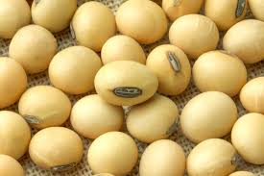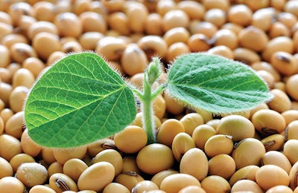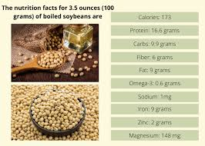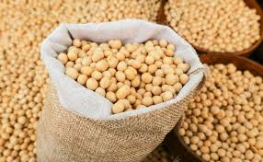 

**MAIZE**

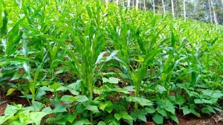  
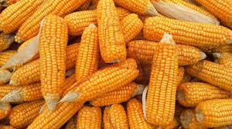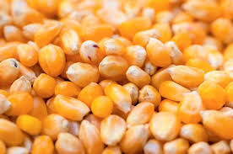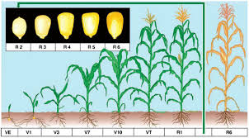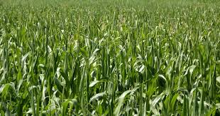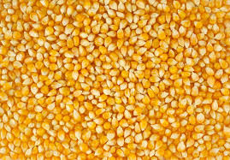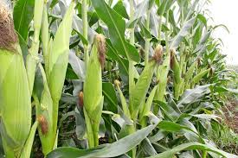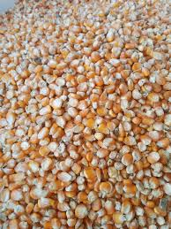

PEGION PEAS

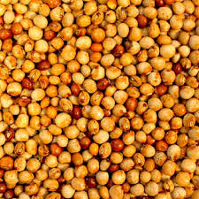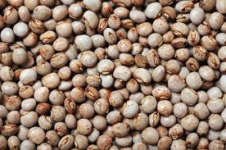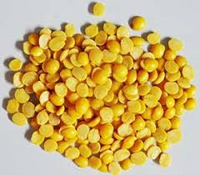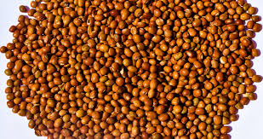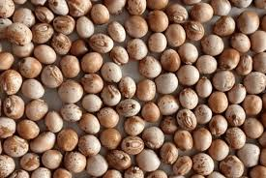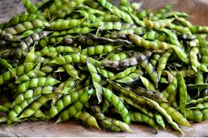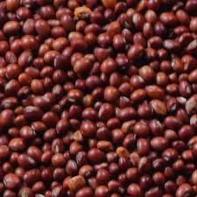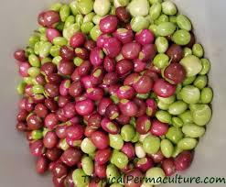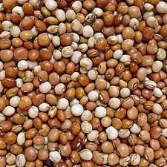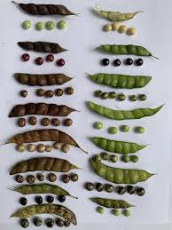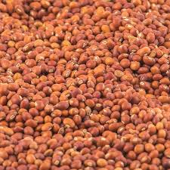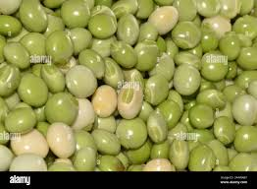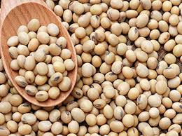

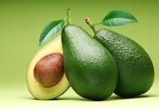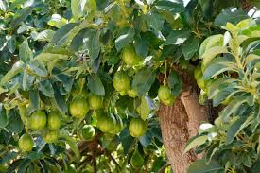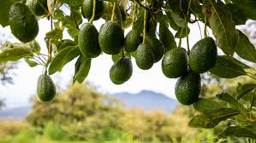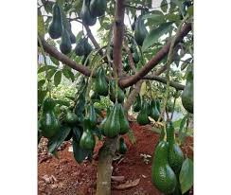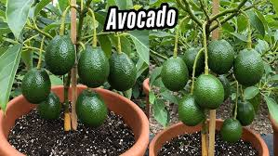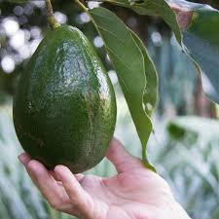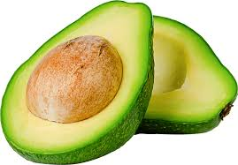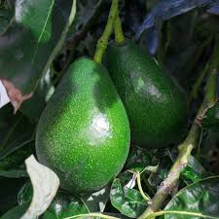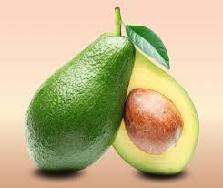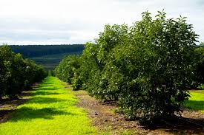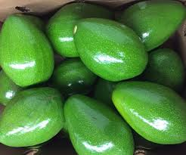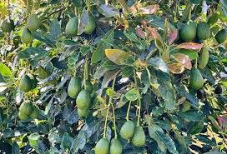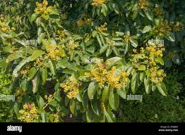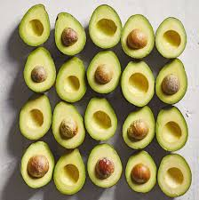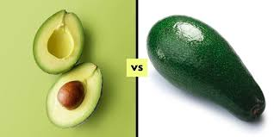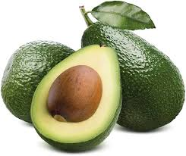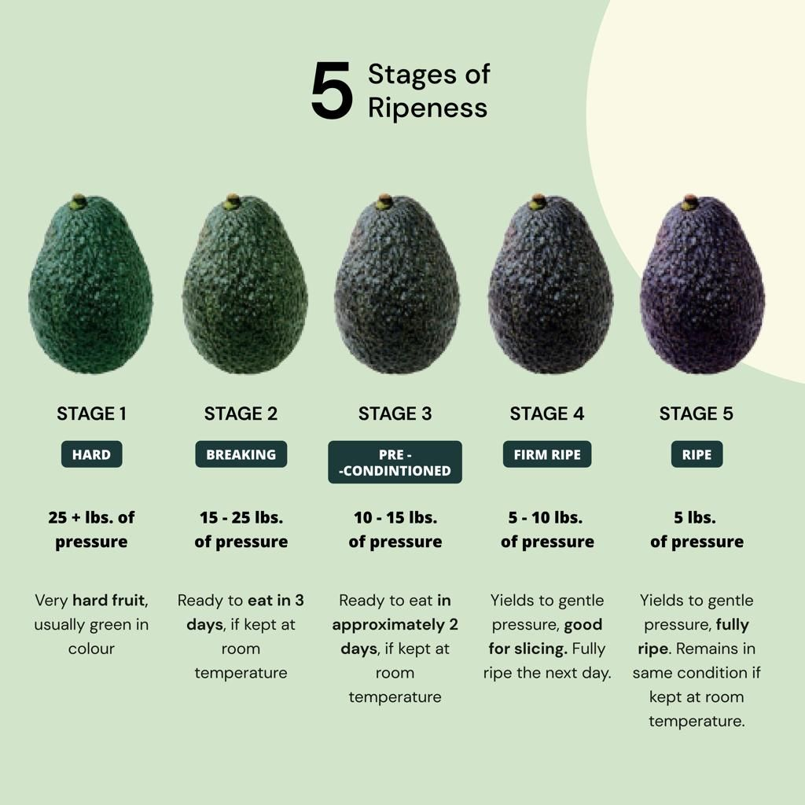

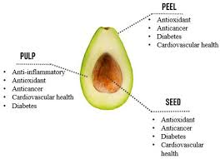

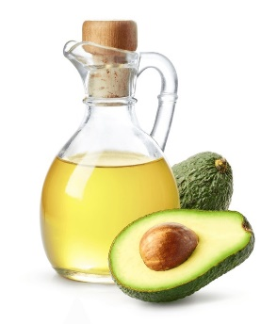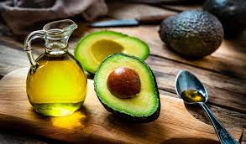

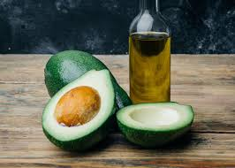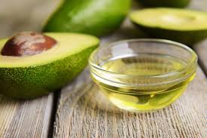

**RICE**

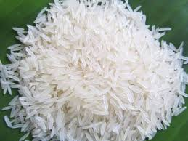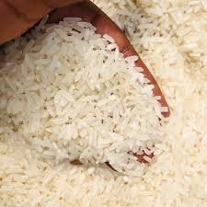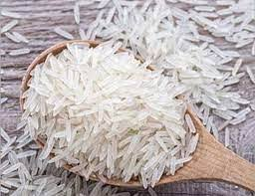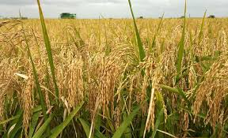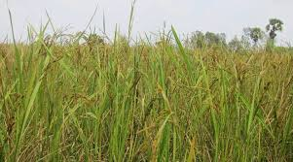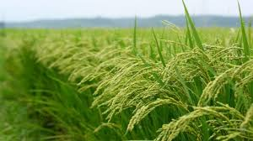

**TIMBER**

****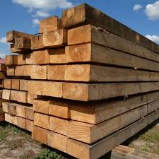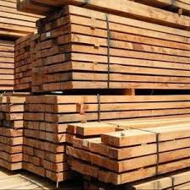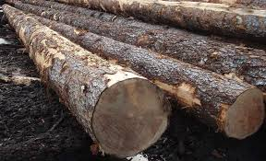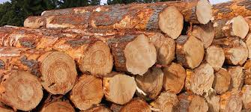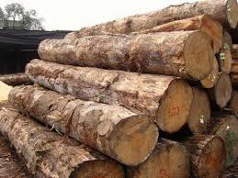****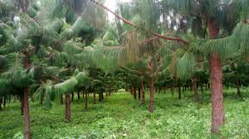****

**EUCALYPTUS VENEER**

